

**The A Team**

**Image Processing Tool for**

**Leidenfrost-Ratchet Systems**

**Plan Document for Version 2.0 (First Draft)**

February 16, 2014

**Authored By:**

Sanan Aamir

Romando Garcia

Anne Lam

James Rowe

Hieu Tran

Table of Contents

1. Introduction 2
   1. Purpose of Plan Document 2
   2. Project Scope and Objectives 2
      1. Statement of Scope 2
      2. Major Functions 2
   3. Overview of Document 3
2. Project Organization 3
   1. Process Model 3
   2. Team Structure 3-4
   3. Communication 4
   4. Reporting 4
3. Project Resources 4
   1. People 4
   2. Hardware and Software 5
4. Risk Management 4
   1. Likely Risks 4
   2. Risk Management Plan 5
5. Schedule 7
   1. Task List and Resource Allocation 6
   2. Time Line 6
   3. Task Network Diagram 6
   4. Objective Grading Sheet 6
6. Tracking and Control Mechanics 7-8
7. Glossary 8
8. References 9

**1. Introduction/Overview**

The plan document details the project planning for the entire development process.

1.1 Purpose of Plan Document

This plan document will set out the resources available to the project, the work breakdown, and the schedule of work for the second version of the Image Processing Tool.

1.2 Project Scope and Objectives

The scope comprises what we intend to implement and nothing more.

. Systeml is pixels to real world distances tool tips/intuitive usesequencege in the sequencetion of the needle and surface lo1.2.1 Statement of Scope

The main objectives of this edition of the tool are to increase automation, improve the user interface, provide graphical data, and speed up processing.

1.2.2 Major Functions

Specific functions to be brought up in this version include:

* Automatic determination of needle and ratchet location
  + if camera position is constant, determine location once using first image in sequence
  + if camera position is altered, determine location for each image in sequence
* Removal of the base image calibration
* Alteration of drop image manipulation (remove white glare)
* Drop volume measurement for each image
* Graphing of various plots using the extracted data
* Improvements to the user interface, including tool tips/intuitive use
* Increased processing efficiency
* Conversion of pixels to real world distances

1.3 Overview of Document

This document restates the project’s objectives and follows with the project’s organization, resources, potential risks and subsequent plan for management, the schedule and tracking mechanics.

**2. Project Organization**

2.1 Process Model

The team will follow the Waterfall software development life cycle. This decision was made due to its simple use and easy to understand style. Also, the requirements are well established and unlikely to be significantly changed.

2.2 Team Structure

The team structure includes James Rowe as project leader, but executive decision making will not be primary to work flow. Everyone in the team inputs their ideas and opinions and decides best paths of actions together. Additionally, all members contribute to documentation via primary authoring or editing. Coding will be split based on functionality, with two pairs of partners focusing on a particular set. James/Mando and Anne/Sanan comprise the partners and Hieu will focus on testing and documentation.

2.3 Communication

Communication will be achieved through a variety of pathways. Weekly meet-ups at the library for the entire team are planned to ensure adequate and correct work is being done. Email, Github, and texting are the main secondary avenues for communication. Additionally, quick meetings in class will ensure focus and reminders of tasks to be done.

2.4 Reporting

Reporting of progress will be done during meetings or through Github issue tracking. Additionally, reports will mark our progress as well.

**3. Project Resources**

The resources to the project include the development team members and the involved hardware and software required to accomplish the development of the tool.

3.1 People

James Rowe is acting project leader and will perform the supervising role and give final say for split decisions. In addition, he and Mando Garcia will handle implementation of including frame rate in the Excel sheet, plotting the data in Excel with automatic graph generation, designing the User Interface, and handling inconsistent image locations. Anne Lam will do the primary authoring of the documentation with assistance from Hieu Tran, and with the rest of the team for editing. Anne and Sanan Aamir will implement the utilization of real world units (opposed to just pixels), calculating and outputting net measurements for velocity and acceleration as well as drop volume, and the fine-tuning of resulting locations of the needle and surface. Hieu is responsible for diagrams, testing and any additional needs as they come up.

3.2. Hardware and Software

Hardware use involves our personal laptops or desktops from where documentation and code will be written. The experiment’s set-up and the hardware associated are not included as the experiment has been completed and put away for the time-being.

Visual Studio and currently undetermined testing software will be used to aid our software development.

**4. Risk Management**

As with any endeavor, there are risks associated that may impede or impact the quality of this product. Recognizing the following potential risks, the team intends to prepare and work as organized and proactive as possible.

4.1 Likely Risks

We believe we may face these common obstacles:

* division of focus because of other responsibilities
* poor communication between team members
* poor time management of specific tasks
* scheduling conflicts between team members and possibly the client
* unforeseen emergencies involving health, family, etc.

4.2 Risk Management Plan

To avoid or alleviate the effects of the previously mentioned risks, the team has identified a few management techniques. These include performing proactive and focused work when given the opportunity in addition to when work is scheduled, and good organization and constant communication. Table 1 below organizes our assessment and plan for the potential risks.

**Table 1.** Potential obstacles that may risk the successful completion of development.

|  |  |  |
| --- | --- | --- |
| **Obstacle** | **Likelihood**  **(1-10 scale, 10 being most likely)** | **Mitigation Techniques** |
| Division of focus because of other responsibilities | 7 | Don’t procrastinate any assignments. Put software engineering first |
| Poor communication between team members | 3 | Use all available means of communication (email, text, face-to-face) |
| Poor time management of specific tasks | 5 | Be organized from the start, equipped with a plan. |
| Scheduling conflicts between team members and possibly the client | 2 | Warn team members of any conflicts that may arise |
| Unforeseen emergencies involving health, family, etc. | 1 | Do as much work while we can. |

1. **Schedule**

5.1 Task List and Resource Allocation

The task list to product development

1. Initial Client Meeting

2. First Draft Document Requirement

3. Final Draft Document Requirement

4. First Draft Project Planning

5. Final Draft Project Planning

6. Design User Interface

7. Coding Stage

8. First Draft Testing Document

9. Final Draft Testing Document

10. Testing Stage

11. Deliver Prototype to Client

12. First Draft User Manual

13. Final Draft User Manual

14. Coding Stage 2

15. Testing Stage 2

16. Final Product Presentation

The A Team has no resource allocation. The team is a group of student working together to achieve a common goal. No money is given, so no money will be allocated.

5.2 Time Line

The time line will be a guide to the development process. It will ensure the team will be on track to deliver a finish product.

See Appendix A for diagram.

5.3 Task Network Diagram

Task Network diagram display the dependency and objective to deliver a working product.

See Appendix B for diagram.

5.4 Objective Grading Sheet

The objective grading sheet will distribute the points to accommodate the task given to each team member.

See Appendix C for diagram.

**6. Tracking and Control Mechanics**

**7. Glossary**

|  |  |
| --- | --- |
| **Term** | **Definition** |
| **Ratchet surface** | A surface that is asymmetrical and periodic. |
| **Leidenfrost-Ratchet System** | A system involving a ratchet surface heated to a fluid's Leidenfrost point will allow a droplet of that fluid to spontaneous accelerate along that surface, even if it means traveling up slope. |

Appendix A – Task Network Diagram

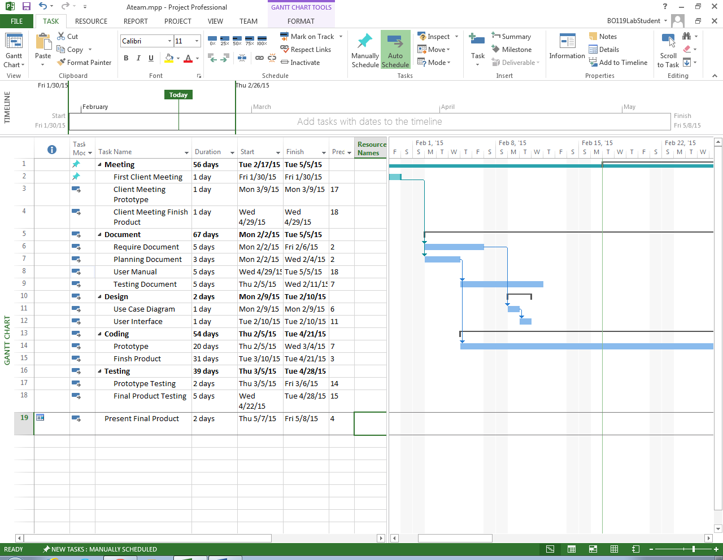

Appendix B – Network Diagram

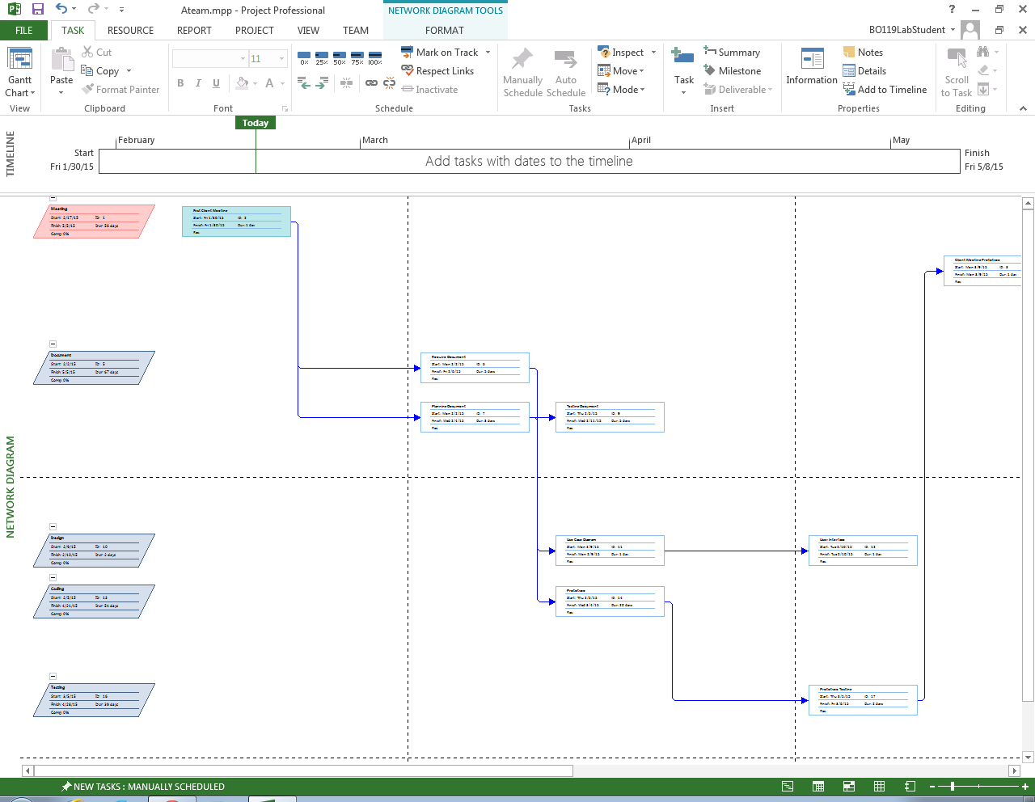

Appendix B – Network Diagram

